|  |
| --- |
| **SOUTHERN CROSS UNIVERSITY** |

**ASSIGNMENT COVER SHEET**

For use with online submission of assignments

Please complete all of the following details and then make this sheet the **first page of each file of your assignment – do not send it as a separate document.**

Your assignments must be submitted as either **Word documents, text documents with .rtf extension or as .pdf documents**. If you wish tosubmit in any other file format please discuss this with your lecturer well before theassignment submission date.

|  |  |
| --- | --- |
| Student Name: | **Jennifer Doherty** |
| Student ID No.: | **22223407** |
| Unit Name: | **Database Systems I** |
| Unit Code: | **CSC00228** |
| Tutor’s name: | **Kathryn Gibney** |
| Assignment No.: | **3A** |
| Assignment Title: | **Enhanced Entity Relationship Diagram** |
| Due date: | **13 May 2016** |
| Date submitted: | **12 May 2016** |

Declaration:

*I have read and understand the Rules Relating to Awards (*[*Rule 3 Section 18 – Academic Misconduct Including Plagiarism*](http://policies.scu.edu.au/view.current.php?id=00140#s18)*) as contained in the SCU Policy Library. I understand the penalties that apply for plagiarism and agree to be bound by these rules. The work I am submitting electronically is entirely my own work.*

|  |  |
| --- | --- |
| Signed:  (please type your name) | Jennifer Doherty |
| Date: | 12/05/2016 |

ASSIGNMENT Three Part A:

Enhanced Entity Relationship Diagram

By Jennifer Doherty

Table of Contents

Entity Relationship Diagram 4

Analysis 5

Client Business Rules 5

Assumptions Made 5

# Entity Relationship Diagram

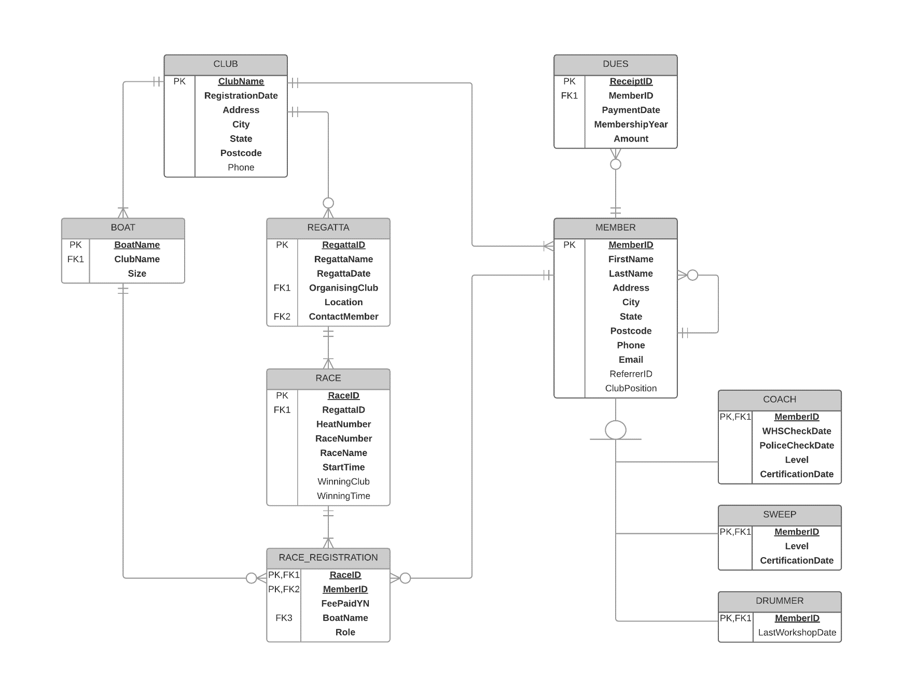

# Analysis

## Client Business Rules

* A new club must have at least four prospective members, who fill the required club positions of President, Vice-President, Secretary, and Treasurer.
* There is a maximum of four boats in each race.
* Only boats of the same size can compete in the same race.
* The certification levels for Coaches and Sweeps range from 1 to 5.
* Annual membership dues may be paid in instalments.

## Assumptions Made

* New club members may be referred by existing club members, but this is not required.
* Attending a drumming workshop is optional – drummers are not required to have any qualification.
* Boat names are unique within the Association.
* Club names are unique within the Association.